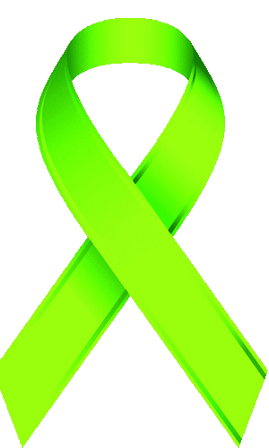
Cape Wide Lyme Disease Support Groups

UPPER CAPE

Spaulding Rehabilitation Hospital Cape Cod/ Sandwich Site
311 Service Road
East Sandwich, MA 02537
Last Monday of Each Month
FF Conference Room
4:00 to 5:00 pm

LOWER CAPE

Spaulding Rehab Outpatient Center
65 Old Colony Way
Orleans, Mass 02653
2nd Tuesday every month 4:30pm – 5:30 pm
Check in at front desk

Cape Cod Covenant Church
11 Satucket Rd, Brewster, MA 02631
(Corner of Airline & Satucket Roads)
3rd Sunday every month 3:00pm – 4:30pm
Park and enter in rear

Anyone with an interest in Lyme is welcome!
Transportation available if needed
All meetings are handicap/ wheelchair accessible and smoke free
Solicitation strictly prohibited

Contact: Lisa C Freeman RNC BSN FCN Lfree125@comcast.net
Cape Lyme Advocacy Support Program (CLASP)

